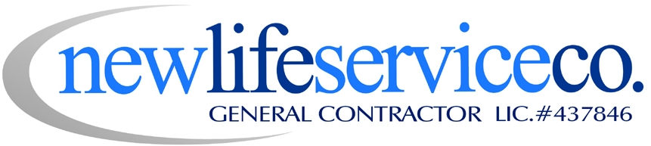

Specializing in Fire & Water Damage Restoration

Job Title: Emergency Services Technician

Job Summary and Mission

This job contributes to New Life Service Co. success by carrying out day to day work orders given by the Emergency Services Manager or Lead. Thereby achieving business results while fulfilling our mission to enrich the lives of others by restoring our customer’s property, supporting our community and developing the next generation in skilled trades. The Emergency Services technician is a working member of the emergency services team. The Emergency Services Technician reports to the Emergency Services Manager or Lead.

Summary of Essential Key Responsibilities
Note: Responsibilities and essential job functions include but are not limited to the following:

- Execute the operation, organization and cleanliness of emergency service assignments, the emergency service warehouse, tools and vehicles.
- Learn characteristics of new systems and equipment of the mitigation industry and update skills to adapt to changing technology.
- Ensure company and customer satisfaction through professional appearance, expert workmanship, and polite communication.
- Attend company meetings as requested by management.
- Responsible for the efficient and profitable use of the company’s time, labor, and materials.
- Protect the company’s property, do not use, nor allow others to use company property without permission and according to policy.
- Uphold site conduct, no abusive or foul language is to be tolerated, radios should be played quietly, music appropriate and absolutely no horseplay.
- Ensure job safety for both the customer and our workers, wear hard hats, goggles, hearing protection, boots, respirators, gloves and containment suits as required.
- Report job progress, potential work obstacles and possible solutions to Lead.
- Responsible for personal and project quality control.
- As workloads fluctuate, you may be assigned to train and work with other departments
- Uphold, coach and hold accountable self and others to our mission and core values:
  - Treat others with Respect and Dignity…
  - Achieve Excellence…
  - Take Personal Ownership…
  - Develop Continuously…

Qualifications: Knowledge and experience with:

- Current practices, materials, hand and power tools, and equipment used in the emergency service industry.
- Contents packing, inventory, and manipulation.
- Safety and Health regulations and practices pertinent to the mitigation industry.
- Harmful effects of hazardous or toxic materials and the protection and safeguards required when working with such materials
- Capabilities in computer applications, systems, and hardware used for emergency services industry.

Required Skills and Abilities:

- Maintain IICRC certification
- Prepare, read, interpret and work from sketches, drawings and plans
- Inventory management and material ordering
- General knowledge of associated building trades
- Maintains high level of craftsman skill in the mitigation industry
- Able to perform heavy physical work around machines
- Operate a motor vehicle
- Position requires vision to read printed materials and computer screens; hearing and speech to communicate in person and over the telephone.
- Able to bend, stoop, kneel, reach and climb to perform work
- Safely climb ladders and work at heights on scaffolds
- Possess the ability to safely lift, carry, push, and pull materials and objects as necessary to perform job functions, up to 100 lbs.

Core Competencies:
(Abilities, knowledge, and skills that enable a person to act effectively in a job or situation)

- Self-motivated
- Humility, Ask for help
- Composure, maturity to be professional
- Works well with others, builds healthy relationships
- Decision making, can work independently
- Problem solver, logical or deductive reasoning for best possible outcome
- Safety conscious, know and adhere to all safety standards
- Teachable, committed to feedback cycle, Growth Mindset
- Detail oriented, training the eye to see specific things related to mitigation work
- Tool savvy, comfort and knowledge in use of tools
- Clear communicator
- Be knowledgeable of customer, scope, budget, industry standards and relevant building codes
- Keep our culture, stand up for our core values

Education:

Any combination of training and experience that would provide the required knowledge, skills, and abilities is qualifying:
- Equivalent to the completion of the twelfth (12th) grade

Environmental Elements:

Employees work in environments with moderate noise levels. The work may involve exposure to moderate chemical odors, confined spaces, and some extreme environmental conditions. (IE Biohazard clean up like sewage or body fluids)

Working Conditions:

The typical work week is Monday – Friday 8:00a-4:30p. It may also include on call status, as required by New Life Service. The nature of our company work is disaster restoration and emergency services. In order to fulfill our commitment to excellent customer service and good community service, we all expect to share the load by making occasional sacrifices of extra work time when necessary.

Note: management reserves the rights to add, modify, change, or rescind the work assignments of different positions and to make reasonable accommodations so that qualified employees can perform the essential functions for the job.

Date Reviewed _____________________________

Employee Name _____________________________

Employee Signature ___________________________

Employer Signature ___________________________

